Standard 10
Documentation of advocating for underrepresented students

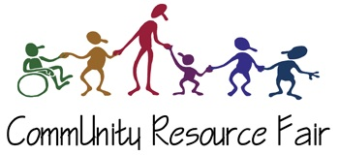
As a school counselor and a minority myself, advocating for underrepresented students is one of my passions. Opening doors for students and their families to succeed in this country is something I tried to do as much as possible during my time at Mariner. I am a firm believer that a student’s academic and behavioral struggles are symptoms of something bigger happening in their lives. Therefore, one of the things I did at Mariner was to co-organize a resource fair for Spanish Speaking parents and students. This fair was organized by the head of the attendance office, who speaks Spanish, the student advocate, and myself. The three of us contacted different organizations that parents and students could benefit from in numerous ways. Some of these organizations included: The Mukilteo YMCA, Familias Unidas, SeaMar, Cocoon HOUSE, Alcoholic Anonymous, Everett Community College, University of Washington Bothell, volunteers of America, and Clothes for Kids. Counselors, the principal, the student support advocate, Mariner’s mental health professional, among other school staff were present for this fair in February 2014. Students and parents were able to gather information, ask questions, and talk to other parents. This fair took a while to organize, but we are proud to say that it was a success.

